**Lab Report No: 02**

**Lab Report Name: Basic Linux command**

Name: Ishrath Mostakin

ID: IT-17018

**1.** What is Linux command?

**Answer :** Linux command is a command line program that accepts text input to execute operating system functions. Linux command is still used by software developers and system administrators to configure computers, install software, and access features that are not available in the graphical interface. You are able to enter commands by typing them on the keyboard and feedback will be given to you similarly as text. The command line typically presents you with a prompt. As you type, it will be displayed after the prompt.

**15 Linux commands :**

1. pwd
2. ls
3. cd
4. man
5. clear
6. mkdir
7. df
8. cp
9. mv
10. find
11. cal
12. free
13. echo
14. sudo
15. du

**Description:**

**1. pwd**: pwd stands for Print Work directory and it shows the directory you’re currently in. It is one of the handiest Linux terminal commands that aims to make new user’s life peaceful by ensuring they don’t get lost in that seemingly cryptic terminal window.

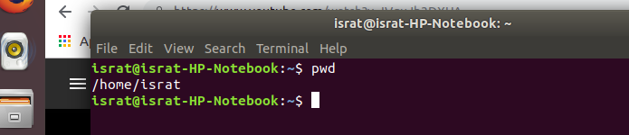

**2. ls**:  ls command presents to you the contents of a particular directory – both files and directories. You will use this command alongside pwd to navigate your ways inside the mighty Unix file system.

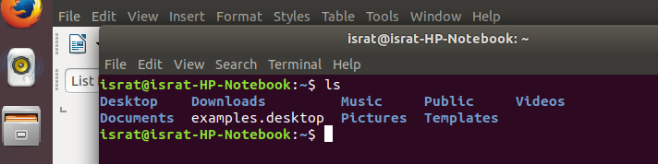

**3. cd**: The cd command - change directory - will allow the user to change between file directories. As the name command name suggest, you would use the cd command to circulate between two different directories.

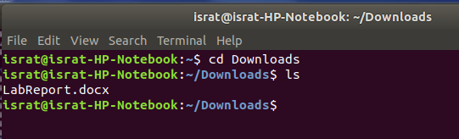

**4.man**: man command - the manual command - is used to show the manual of the inputted command. Just like a film on the nature of film, the man command is the meta command of the Linux CLI. Inputting the man command will show you all information about the command you are using.

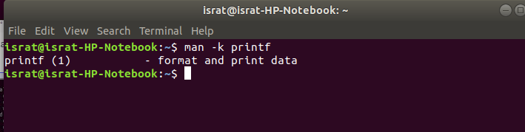

**5. clear**: clear command does exactly what it says. When your Linux CLI gets all mucked up with various readouts and information, the clear command clears the screen and wipes the board clean. Using the clear command will take the user back to the start prompt of whatever directory you are currently operating in. To use the clear command simply type clear.

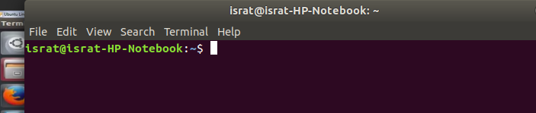

**6. mkdir**: mkdir command in Linux allows the user to create directories (also referred to as folders in some operating systems ). This command can create multiple directories at once as well as set the permissions for the directories.

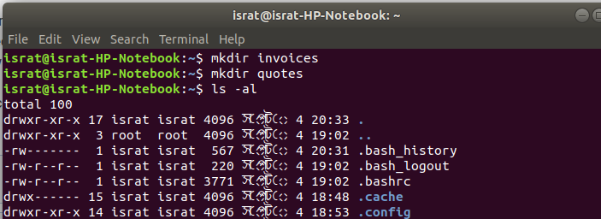

**7.df** : The df command is used to display information related to file systems about total space and available space. If no file name is given, it displays the space available on all currently mounted file systems.

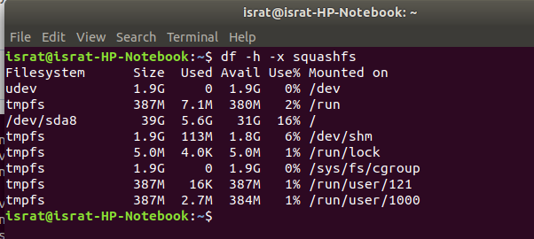

**8. cp** : Use the cp command to copy files through the command line. It takes two arguments: The first is the location of the file to be copied, the second is where to copy. It supports moving one or more files or folders with options for taking backups and preserving attributes.

**9. mv** : The mv command - move - allows a user to move a file to another folder or directory. Just like dragging a file located on a PC desktop to a folder stored within the "Documents" folder, the mv command functions in the same manner. It can prompt before overwriting and has an option to only move files that are new than the destination.

**10. find** : Linux Find Command is one of the most important and frequently used command command-line utility in Unix-like operating systems. Find command is used to search and locate the list of files and directories based on conditions you specify for files that match the arguments.

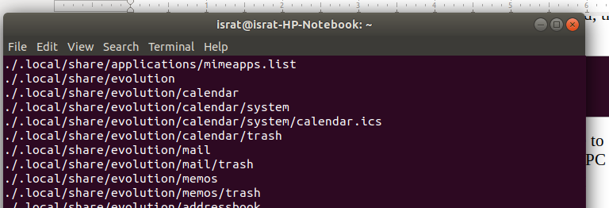

**11. cal**: The cal command is one of those funny Linux commands that shows you the calendar in an ASCII text format. Type this command with parameters like month and year to get specified information right into the terminal.

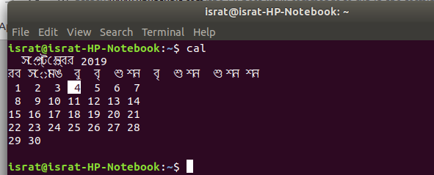

**12. Free**: free command gives you a summary of the memory usage with your computer. It does this for both the main Random Access Memory (RAM) and swap memory. The -h (human) option is used to provide human-friendly numbers and units. Without this option, the figures are presented in bytes.

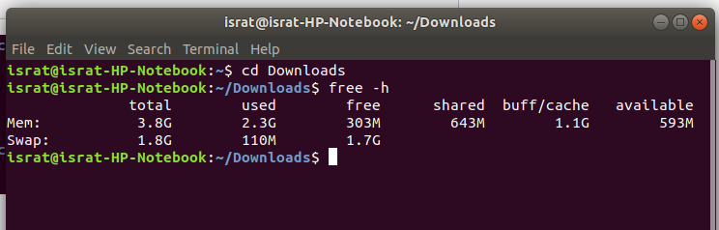  
**13.echo:** echo command in linux is used to display line of text/string that are passed as an argument . This is a built in command that is mostly used in shell scripts and batch files to output status text to the screen or a file.

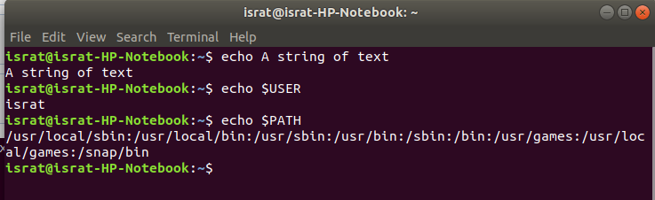

**14. sudo** : The sudo command is the holy grail of Linux commands. It lets non-privileged users access and modify files that require low-level permissions. Often you will use this command to access root from your regular user account.

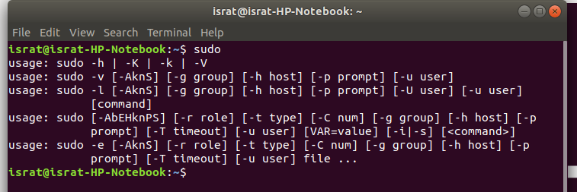

**15. du** : du command, short for disk usage, is used to estimate file space usage. The du command can be used to track the files and directories which are consuming excessive amount of space on hard disk drive. –apparent-size : print apparent sizes, rather than disk usage.

